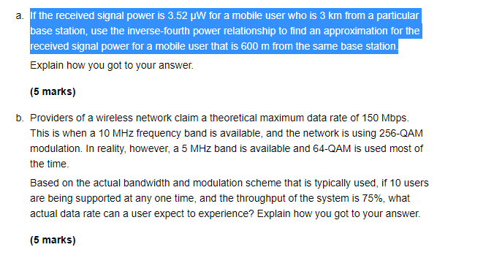
- I= (3.52*3000^4)/600^4
= 11137.5uW
- W= rb/log 2(M)
= 5*10^3*10)/log 2(64)
= 3Mbps

-QA
‘#

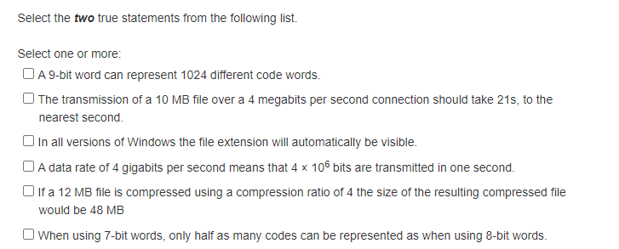
1st and last choice
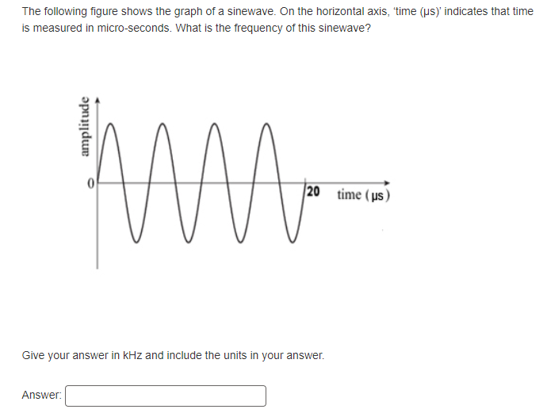
Answer 200kHz
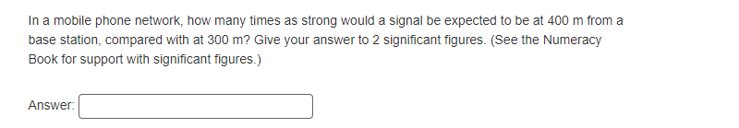
Answer 0.56
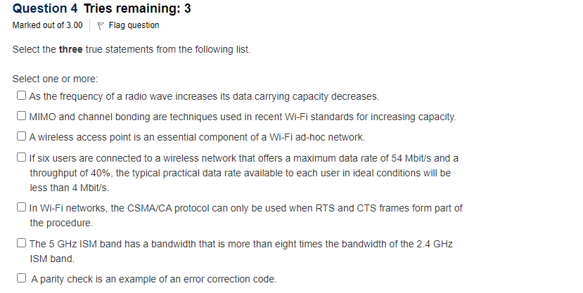
Question 4. 1st,3rd and last choice
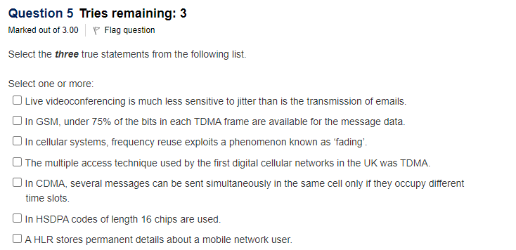
Question 5 answer 2nd, 3rd and last choice

?##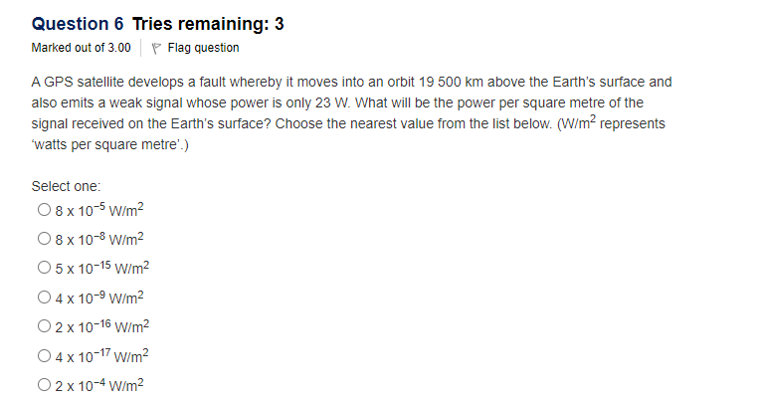
Question 6: 5*10^-15W/m²
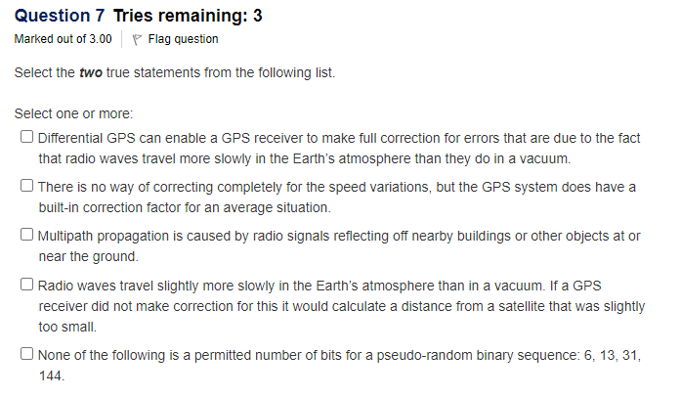

Question 7: 1st, 2nd, and last choice

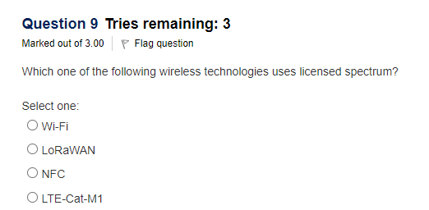
Question 9: LTE-Cat-M1
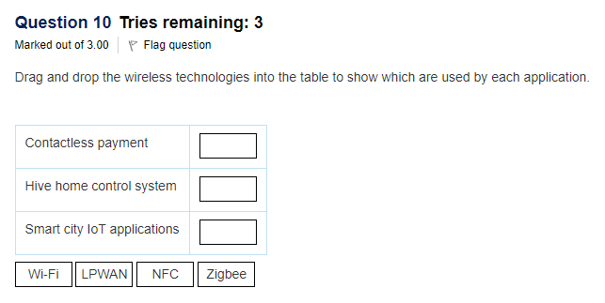

Question 10.
Contactless payment | NFC
Hive home control system | Zigbee
smart city IoT applications | LPWAN

